Lab 14

A1) Done

A2)

import java.awt.Graphics;

import java.awt.Graphics2D;

import java.util.ArrayList;

import javax.swing.JComponent;

/**

This component draws two car shapes.

*/

public class CarComponent extends JComponent

{

private ArrayList<Car> cars;

private static final int TEST_AMOUNT_CARS = 5;

public CarComponent()

{

cars = new ArrayList<Car>();

for (int i = 0; i <= TEST_AMOUNT_CARS-1; i++)

{

cars.add(new Car(30*i, 30*i));

}

}

public void paintComponent(Graphics g)

{

Graphics2D g2 = (Graphics2D) g;

for (int i = 0; i<= cars.size()-1; i++)

{

cars.get(i).draw(g2);

}

}

}

A3)

import java.awt.Graphics;

import java.awt.Graphics2D;

import java.util.ArrayList;

import javax.swing.JComponent;

/**

This component draws two car shapes.

*/

public class CarComponent extends JComponent

{

private ArrayList<Car> cars;

private ArrayList<House> houses;

private static final int TEST_AMOUNT = 5;

private static final int CAR_HEIGHT = 30;

public CarComponent()

{

cars = new ArrayList<Car>();

houses = new ArrayList<House>();

for (int i = 0; i <= TEST_AMOUNT-1; i++)

{

cars.add(new Car(0, CAR_HEIGHT*i));

houses.add(new House(100, 80*i+80, 50, 50));

}

}

public void paintComponent(Graphics g)

{

Graphics2D g2 = (Graphics2D) g;

for (int i = 0; i<= cars.size()-1; i++)

{

cars.get(i).draw(g2);

houses.get(i).draw(g2);

}

}

}

A4)

DONE

A5) DONE

import java.awt.Graphics;

import java.awt.Graphics2D;

import java.util.ArrayList;

import javax.swing.JComponent;

/**

This component draws two car shapes.

*/

public class SuburbanScene extends JComponent

{

public ArrayList<Drawable> drawables;

private static final int TEST_AMOUNT = 5;

private static final int CAR_HEIGHT = 30;

public SuburbanScene()

{

drawables = new ArrayList<Drawable>();

for (int i = 0; i <= TEST_AMOUNT-1; i++)

{

drawables.add(new Car(0, CAR_HEIGHT*i));

drawables.add(new House(100, 80*i+80, 50, 50));

}

}

public void paintComponent(Graphics g)

{

Graphics2D g2 = (Graphics2D) g;

for (int i = 0; i<= drawables.size()-1; i++)

{

drawables.get(i).draw(g2);

}

}

}

A6) Done

A7) Done

A8) Done

A9) Done

A10)

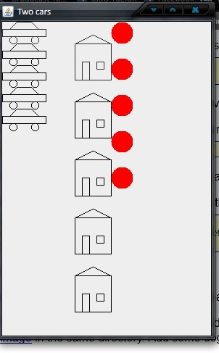

B1) DONE

B2) Done

B3) DOne

B4) public void paintComponent(Graphics g)

{

Graphics2D g2 = (Graphics2D) g;

for (int i = 0; i<= drawables.size()-1; i++)

{

if (drawables.get(i) instanceof Moveable)

{

Moveable moving = (Moveable) drawables.get(i);

moving.move();

Drawable d =(Drawable) moving;

d.draw(g2);

}

else drawables.get(i).draw(g2);

}

}